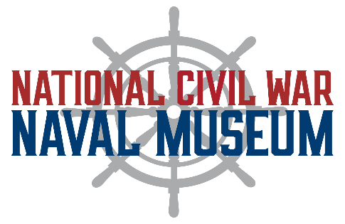
FACILITY RENTAL AGREEMENT

Name of Organization:
Person Authorized to Sign for the Organization:
Address:
Phone: Email:
Name of Event:
Date of Event: Anticipated Attendance:
Time Event is to Begin: Time Event is to End:
Time Set-up is to Begin: Time Clean-up will be Complete:

RENTER agrees to abide by the policies and conditions outlined in this contract. RENTER agrees to designate one person as HOST to be responsible for all aspects of event planning, preparation, and event supervision. The HOST must be present during the entire event to ensure that this agreement and all its policies are followed by guests and service providers, and to see that the museum is cleaned up after the event.
If the HOST is different from the Authorized Contact Person listed above, please include the name and contact information of the person in charge of the event:

Host:
Phone: Email:

RENTAL FEES

Rental Fee: Overlook Gallery $125/ hour for a min. of 3 hours.
Seats a max. of 50 guest.
*Includes set-up, event, and clean up. *
Deposit Refundable (see next page)
Additional Charges
Additional Charges
Additional Charges
TOTAL RENTAL FEE:
(minus) 25% Deposit: To be paid upon signing this
contract.
BALANCE: DUE 30 DAYS PRIOR TO
EVENT.

- The Rental Fee includes the use of the MUSEUM’s tables and chairs.
- MUSEUM does not provide linens.
- Museum staff are not allowed to set up RENTER’s rented equipment, including rented tables and chairs.
- Rentals that occur during normal museum operating hours will not be private.

CANCELLATION POLICY
If the renter cancels the event within 30 days prior to the scheduled date, 10% of the total rental fee is nonrefundable. In the event the museum cancels the rental agreement, the limit of liability will be refund of fees paid to the museum.

FACILITY RULES & REQUIREMENTS
- A $200 refundable Deposit is required upon signing this contract. The deposit will be kept should there be…
  - ANY damage to the museum,
  - ANY remaining clean up for museum staff AFTER the event,
  - an EXTENSION of the agreed upon rental period,
  - ANY last minute changes.
If none of the above issues occur, the check will be returned by mail, after the event.
- MUSEUM RESERVES THE RIGHT TO DENY FACILITY USAGE TO ANY GROUP, FOR ANY REASON, AT ANY TIME.
- Museum staff representative at the rental event has the authority to act, make decisions, and cancellations which are in the best interest of the MUSEUMs safety, security, and image.

Initials/Date
- Ticketed events, fund-raisers, political, for-profit events or otherwise, are not permitted.

DECORATIONS
- Decorations may NOT be attached to any surface (walls, exhibit cases, etc.).
  - All decorations must be free standing (floor or table).
- Birdseed, glitter confetti, rice, silly string, tinsel, and sparklers are NEVER allowed on the property – inside or outside.
  - No open flames or candles (EXCEPTIONS may be made for cake candles and sternos for food service).
- ALL decorations are subject to Museum staff approval.

SET UP/ BREAK DOWN/ CLEAN-UP
- The museum DOES NOT provide storage for outside-rental equipment or goods and assumes no responsibility for loss and damage to items.
- HOST IS RESPONSIBLE FOR all clean-up and for ensuring that the museum is returned to the way it was found prior to the event.
- ALL garbage will be placed in the dumpster behind the Museum at the end of the event.
- RENTER IS RESPONSIBLE FOR all damage to carpet, walls, building, exhibits, etc.

Host Initials Here____________

ALCOHOL POLICY
*NO ALCOHOL SALES ARE PERMITTED. *
SMOKING POLICY
*NO SMOKING, NO TOBACCO USE, AND NO VAPING IN THE MUSEUM. *

BOTH PARTIES AGREE AND UNDERSTAND THAT
- This Agreement contains the entire agreement of the parties and supersedes all prior discussions and agreements between parties and any prior agreements shall, from and after this date, be invalid. This agreement may not be changed orally, but only by an agreement in writing signed by MUSEUM and HOST.
- This agreement is executed, delivered, and intended to be performed, and shall be constructed and enforced in accordance with and governed by the laws of the State of Georgia.

HOST Signature Date

MUSEUM Representative Date

